1. Introduction to Swarm Search

2. Real-Time Swarm Search Method for Real-World Quadcopter Drones

3. The Game of Drones:rapid agent-based machine-learning models for multi-UAV path planning

4. Swarm Path Planning for the Deployment of Drones in Emergency Response Missions

5. Search and rescue with autonomous flying robots through behavior-based cooperative intelligence

6. A Probabilistic Target Search Algorithm Based on Hierarchical Collaboration for Improving Rapidity of Drones

7. Multiobjective coordinated search algorithm for swarm of UAVs based on 3D-simplified virtual forced model

8. Multi-UAV based Autonomous Wilderness Search and Rescue using Target Iso-Probability Curves

9. UAV SWARM PATH PLANNING

10. UB-ANC planner: Energy efficient coverage path planning with multiple drones

11. Multiple UAV cooperative searching operation using polygon area decomposition and efficient coverage algorithms

##### 1. [Introduction to Swarm Search](https://sci-hub.do/https://doi.org/10.1007/978-3-319-63604-7_1)

* General overview of the field, not specific to our use case
* Lots of good references

##### 2. [Real-Time Swarm Search Method for Real-World Quadcopter Drones](https://www.researchgate.net/publication/326503944_Real-Time_Swarm_Search_Method_for_Real-World_Quadcopter_Drones)

* Leverages “particle swarm optimization algorithm”
* Iterative evidence-based position update mechanism
  + Example: find point with highest pheromone level
  + Because our “evidence” is entirely binary (target in frame, target not in frame), this approach does not seem applicable to our problem

##### 3. [The Game of Drones:rapid agent-based machine-learning models for multi-UAV path planning](https://sci-hub.do/https://doi.org/10.1007/s00466-019-01761-9)

* Iterative planning approach taking into account fixed target points, obstacle points, and member (drone) points
  + Member points used to avoid collision
    - This is inherently timing-based which is not ideal due to wind
  + Fixed target points in our case would be a set of evenly(?) spaced points throughout the search area polygon
    - This may not be sufficient as we need to ensure full area coverage, taking into account camera FOV?
  + In our case, obstacle points are initially unknown
    - Currently think we plan to keep drones at sufficient altitude to not worry about obstacles
    - If we care, could do an initial sweep at a high altitude to
    - Unclear what the effects of adding obstacles mid-search would be
* Uses ML genetic algorithm with a post-processing gradient algorithm to optimize search
  + Unclear if derived weights are reusable or if this training must occur for every search scenario (probably the latter…)
    - Training took 4+ minutes for the paper scenario, so ideally we wouldn’t have to do live training
      * Also would be a major battery drain for real onboard compute

##### 4. [Swarm Path Planning for the Deployment of Drones in Emergency Response Missions](https://sci-hub.do/10.1109/ICUAS48674.2020.9213876)

* Distributed graph traversal approach
  + Arc cost is weighted by distance for battery life considerations
* Seeks minimal flight time with maximum nodes visited
* Assumes weather conditions do not limit velocity
* Does not account for drone camera in area coverage - solely node-based
* No direct considerations for collision avoidance
* Compares several different heuristics with each having coverage advantages
  + We could consider automatically switching between approaches based on coverage when needed

##### 5. [Search and rescue with autonomous flying robots through behavior-based cooperative intelligence](https://jhumanitarianaction.springeropen.com/track/pdf/10.1186/s41018-018-0045-4.pdf)

* Focused on multi-target scenarios
  + Explores a few different control methods: standard, spiral, and scatter
    - In standard, drones fly in formation through set of waypoints
      * Search pattern for order and placement of waypoints is extremely ambiguous
      * In theory formation maximizes visibility when going through waypoints
    - In spiral, standard method but one breaks off to spiral around ‘evidence’ when located
      * Only applicable if we’re taking into account “positive-signs”
      * “Expanding-square” algorithm but with a circle
    - In scatter method, drones collaboratively claim and fly to waypoints based on “staleness” - no formation in this approach
    - Unclear what the “search pattern” as part of the standard and scatter methods is...
* No pre-planning - seems to be completely reaction-based
  + Relies on location broadcasting to avoid collisions - maintains set distance between drones
* Covers things from an architectural perspective as well
  + Priorities for certain behaviors
  + 60Hz sensor checking loop
* Camera is “down-mounted” (looking straight down?)
* Obstacle avoidance (but not detection) algorithms
  + Bouncing method: When obstacle encountered, accelerate at 200deg heading, try moving forward again, change deflection angle if in one place for too long
  + Climbing method: When obstacle encountered, ascend

##### 6. [A Probabilistic Target Search Algorithm Based on Hierarchical Collaboration for Improving Rapidity of Drones](https://sci-hub.do/10.3390/s18082535)

* Layered altitude approach
  + “stochastic”
  + First scan area with high-altitude drone(s), then more detailed focus in probable areas with low-altitude drones (though some of this is concurrent)
    - High altitude = low quality, larger range
    - Low altitude = high quality, lower range
    - Altitude is most important factor for search quality
    - Probability can be based on environmental features, direct target detection, ...
* Divides search area into cells
  + Coverage movement within cell is unclear
* Domain overview (related works)
  + Briefly mentions a few different alternative search strategies (see refs)
    - Random-walk
    - Sweeping
    - Myopic
    - Drosophila-inspired
    - Saccadic
  + Three algorithm classifications
    - Greedy heuristics
      * Selects neighbor cells with highest probability of target existence
    - Potential-based
    - Partially observable Markov decision process (POMDP)

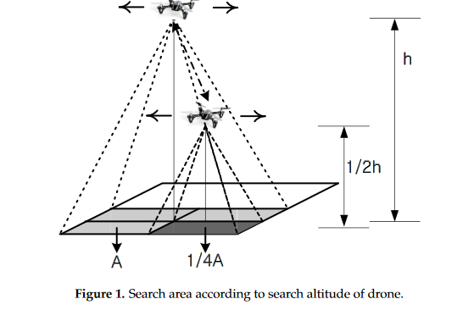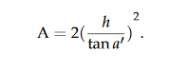

##### 7. [Multiobjective coordinated search algorithm for swarm of UAVs based on 3D-simplified virtual forced model](https://sci-hub.do/10.1080/00207721.2020.1799110)

* Background: Target search is mainly based on two types of behavioral algorithms
  + Swarm intelligence optimization algorithms (coordinated search)
  + Random walk strategies (roaming search)
    - Several models
      * Levy Flight
      * Intermittent Search
    - Disadvantages: search efficiency is not high and the obstacle avoidance factor is not considered in the search process
* Heavy focus on real-time collision and obstacle avoidance
* When no evidence of target, use roaming model - when evidence of target found, use coordinate search model
  + Paper use case is finding highest energy level, so only the roaming portion may be applicable
    - However, coverage of roaming model is limited… so maybe this paper isn’t useful

##### 8. [Multi-UAV based Autonomous Wilderness Search and Rescue using Target Iso-Probability Curves](https://sci-hub.do/10.1109/ICUAS.2019.8798354)

* Derives areas of probability from known information (terrain, last known location + time, …), focuses search in higher probability areas
  + Probability is a function of wandering
* Could combine concept of searching iso-probability curves with [6]
  + Otherwise, since we don’t have last-known location (I think? Confirm with Dan), can’t apply the overall search strategy proposed by this paper

##### 9. [UAV SWARM PATH PLANNING](https://sci-hub.do/10.1109/ICNS50378.2020.9223005)

* Collision-avoidance planning algorithm for optimizing drone separation while driving to their destinations
  + NOT a search algorithm
* Intended for real-time usage - has considerations for latency, out of range drones, …

##### 10. [UB-ANC planner: Energy efficient coverage path planning with multiple drones](https://sci-hub.do/10.1109/ICRA.2017.7989732)

Github: <https://github.com/jmodares/UB-ANC-Planner>

* Heavy focus on energy efficiency in coverage
  + Optimizes distance, number and magnitude of turns in path
    - Speed is NOT a consideration in this approach - does not really fit our general use case
      * However, we should look at balancing speed and energy costs and thus should consider turns/turn magnitude in our approach… but don’t need to completely minimize energy as this approach does
* VRP (vehicle routing problem), which is a more general case of the multiple traveling salesman problem (mTSP)
* Divides space into grid cells represented as graph, assumes cell is covered if drone reaches center
  + Distribution of cells is “fair” and done through “mixed integer linear programming (MILP)”
  + This load-balancing sub-problem approach may be of interest

##### 11. [Multiple UAV cooperative searching operation using polygon area decomposition and efficient coverage algorithms](https://sci-hub.do/https://doi.org/10.1007/978-4-431-35873-2_22)

* *Convex* polygon division
  + Division accounts for UAV capabilities
  + References a solution for nonconvex polygons
  + Covers case of lost UAV mid-flight
* Assumes fixed orientation cameras
  + Not our case with Parrot ANAFI
* Zig-zag flight pattern within areas
  + Seeks to minimize number of turns in an area
    - Target is time saving, but as shown in [10] is also energy-saving

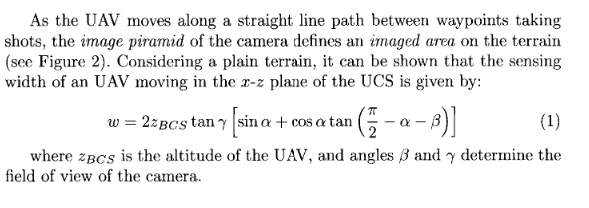

##### 12. [Aerial remote sensing in agriculture: A practical approach to area coverage and path planning for fleets of mini aerial robots](https://sci-hub.do/https://doi.org/10.1002/rob.20403)

* Background:
  + Two types of collaboration
    - Tight cooperation
      * Requires a continuous coordination between the robots
    - Loose cooperation
      * Requires coordination at the beginning of the mission for planning a division of labor, or when replanning is required
* Negotiation protocol for planning based on Rubinstein’s alternate-offers protocol
  + Each agent will try to maximize its reward by (i) trying to get a subtask as big as possible and (ii) minimizing overlapping with other agents’ tasks
    - With this method, each agent is responsible for handling its limitations in selecting subtasks
* Mention of polygonal cell decomposition methods
  + “Sukharev grid”
  + Mention of FOV: fixed altitude to ensure full visibility of cells when at center

TSP: single person

mTSP: multiple people, one ‘depot’ point (in our case, drone home)

VRP: vehicle-oriented mTSP variants, not really applicable to our problem